**CHAPTER-1**

**INTRODUCTION**

* 1. **COMPANY PROFILE:**

**Javonic Websoft Pvt. Ltd.**

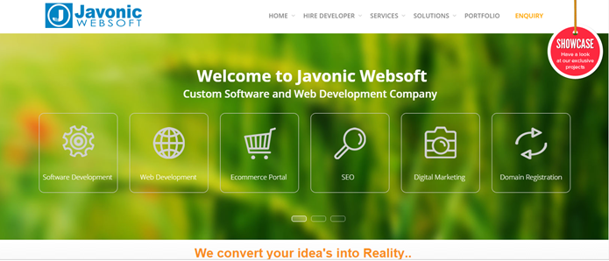

**Figure: 1.1**

Javonic learning is today a premium destination for academic excellence, having successful in IT education and training, live industrial training, project training and career oriented training. Javonic learning strives to bridge the gap between academic educations to industry requirement and meet the specific demand of industry by continuous enhancing its curriculum through strategic industry and academic alliance with leading IT training. Javonic learning’s aim to provide its student with the best possible education and transform them into the most sought after the professional in service industry. After all a right training makes professional.

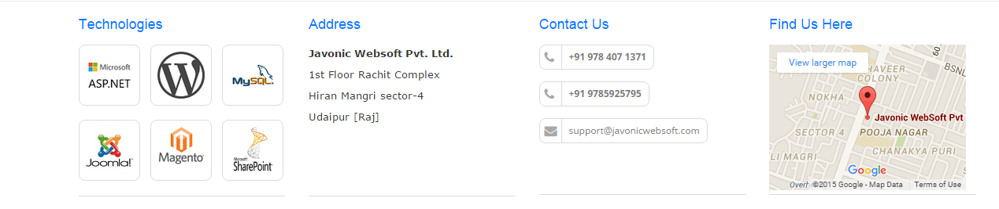

**Figure: 1.2**

**1.2 Why choose Javonic**

At Javonic Websoft, we have more than 20+ technical professionals including Project Managers, Programmers, Mobile app developers and other industry experts, exhaustively working, procuring and perfecting your way to success. Our extensive technical knowledge and comprehensive approach towards software, and Web app development technologies provides you with most virtuous results.



**Figure: 1.3**

We have our own pre defined standards to work on and that helps us to maintain the efficacy and accuracy of deliverables.



**Figure 1.4**

We Are a Company "Javonic WebSoft Pvt. Ltd. Udaipur (Raj.), we are the best IT development company. We have developed a number of websites, desktop and mobile apps and custom software solutions in the verticals of hospitality, healthcare, media & entertainment, education, manufacturing, online retail, telecom, lifestyle industry and other service establishments. We have grown as a premier technology company and a business unit through our knowledge and precisions. We penetrated the market propositions dynamically to touch all the segments and spheres of life. We have corresponded with all the departments, operational segments and dimensions of work and helped organizations to apply the information practices most profitably.

**1.3 Management & People:**

We are a team of highly motivated individuals, belonging to dynamic work backgrounds. The work culture we foster at Javonic Info Solution produces complete professionals who continually hunt for great possibilities and crave for accomplishment, taking all pride in the idea of shared growth. Javonic is lead by highly charged and supremely talented team of industry experts. Our management includes highly prestigious names across and has members with vast knowledge and extensive experience in the domain. We are democratic in our approach, thinking, and work in a close-knitted environment. We involve everyone working in the organization in community decisions and encourage them to think is a broader perspective. Our work process promotes flexibility and we maintain high level of discipline at different levels of execution, throughout the organization. Besides their unparallel contribution towards the professional facets, our management has worked dedicatedly towards the reforms at society level and growth at industry front. The board have not only encouraged the value-driven approach in the organization but also worked towards betterment of the environment we operate in through its green policies and CSR activities.

Javonic Info Solution is an India based software and mobile app development company, that never restricts itself to any particular convention or technology bar. We invite the changes as they come, and utilize them with our expertise and knowledge combined, to serve something unique and innovative to the users. We arrange for most advanced set of resources to build impactful designs, devise substantial plans and come up with most definitive outcome. This helped us to provide the best of the solutions to different organizations and put across extensive solutions that helped them perform dynamically in their work environment. Our steadfast approach and astute vision have made it possible for us to deliver solutions that required a lot of research and involved a lot of uncertainties, besides a lot of domain acquaintance. We are a software development company in India that believes in doing something futuristic and out-of-the-box. We have framed highly intuitive designs and impactful components that have worked wonders for our patrons across the globe.

## 1.4 Excellent Team:

With their immaculate ability and proficiency to handle any sort of challenges in assignments and change in technology and work environment, you get the most proficient and authentic solution for your project, in the best equations of time and cost. We develop perfectly aligned and highly productive solutions across a wide array of utility and benefits.

We have extremely skilled Project managers, programmers, designers and mobile app developers working with us who are highly competent to serve you with amazing solutions and striking possibilities.

**1.5 Overview:**

Javonic Websoft is a software & Web app development company that leads its way in infrastructural presence. Our advanced production facility is located strategically at top business destinations of India. With our excellently laid hardware and software environment, our planned system of work refers to the best of the technology parameters and development tools. Our well-designed communication proponents and sophisticated support system have facilitated dynamic approach in our work setting. We ensure the right balance of work and fun through our eminent infrastructure design. We have provided for smartly designed spaces for different activities and interactions to take place. Canteen, meeting hall, conference area and training labs are sized just perfectly to suit the organizational needs. We have privately-held spaces for support cell, server room and separate seating areas for technical, business and creative departments. All these facilities ensure an energetic environment that increases the production capacity of project managers, programmers & developers and the entire work force. With this we encourage self-motivated temperament to work enthusiastically under any amount of pressure and at any level of complexity. Data security is taken very seriously at Javonic Websoft. To avoid any data theft or loss we protect it through a Firewall, Active Directory policies, handle it with security tools and selective network access. Our internal communication system is wire-framed with an intranet that ensures an automated system of correspondence between the workforces. This helps us follow a complete process-driven approach that includes tools to help users respond quickly, assertively and flawlessly. Few important components used in our standardized internal communication include timesheets, flaw management, resource plan sheet, project route plan, status reports etc. Our project management system is consistently available to clients for uninterrupted review and monitoring purpose. Through this competent system of work we ensure that there remains least chance of miscommunication and no lacuna in between any two members, entities and attributes that contribute to the project development.



**Figure: 1.5**

**1.6 Technologies:**

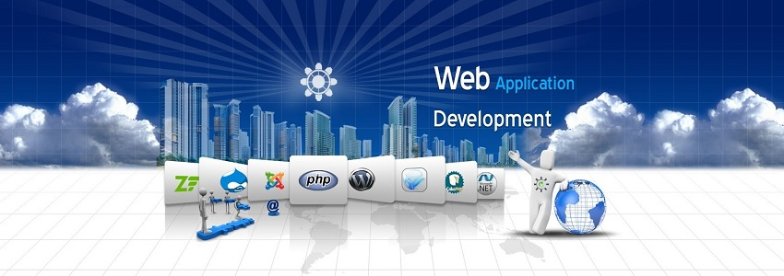

**Figure 1.6**

**1.6.1 Web Design:**

Prepare for a career as a professional website designer crafting the look, layout, and organization of websites. The applications and concepts for this emphasis include HTML, Dynamic html, Photoshop, CSS, jquery, flash, Dreamweaver, style sheets, information architecture and graphical design concepts.

**1.6.2 Web Development:**

Prepare for a career as a professional web developer managing the functional aspects of websites. The applications and technologies for this emphasis include web design techniques and also development programming tools like C#, SQL Server, Asp.Net, Asp.Net Ajax, XML, Crystal report, domain registration, web hosting and many other web development tools.

**1.6.3 Software Development:**

Prepare for a career as a professional software developer managing the functional aspects of software development. The application and technologies for this emphasis include programming in VB, VB.NET, programming with ADO.Net, Custom control, Crystal report, Setup & development, client and server software , software testing, troubleshooting, SDLC.

**1.6.4 Technology:**

Technology is the practical application of skills. It is the logical treatment of science and art. Our latest knowledge is circular in its motivation. Now these days, our society has had the benefits of having current technology.

Information Technology is a fast growing industry. New architecture and multiplying software platforms are forcing the application development to undergo a massive sea change in technologies.

We works with all latest technologies, such as Microsoft technologies, all types of open sources, all kind of frame works, various types of plate forms & design studios etc. Microsoft technologies are the best & latest technologies, which are used in development of any website or webpages. The Microsoft technologies, we working with are MVC frame work, all versions of Microsoft visual studio & SQL server, Microsoft access etc. we also provides all types of open sources developments, such as Joomla development, WordPress development, Drupal development, Magento development, OS commerce etc. Open Source basically refer to the similar software licenses, with a little minor exceptions.

Our experts team is capable to work on all kinds of platforms & frame work, such as Java, ASP.net, Android, I-phone, PHP, Zend framework, Ruby on Rails development, PHP DevShell development etc. Our each member of website designer team, is fully capable to work with latest designing tools, such as Flash, Web 3.0, Dreamweaver CS5, and Photoshop CS5 and many more.



**Figure: 1.7**

## 1.7 How we produce healthy product:

### 1.7.1 Open Sources:

Open source is an approach to the design, development, and distribution of software. It offers practical accessibility to a software's source code. The term open source gained esteem with the rise of the Internet, which provided access to various production models, communication paths, and interactive communities.

### 1.7.2 Mobile Application:

Today if you don't own the latest gadget or a technology product, you are not moving at the pace the world is moving and you are deprived of what others are enjoying. Having the best thing with you increases your chances of sweeping advantages, chances and benefits over others much easily.

### 1.7.3 Web Design & Graphic Design:

The rich graphics on your website and a beautiful logo can do wonders when it comes to attracting users to your websites. We at Javonic software understand our clients and their requirements. Our expert web designers can provide creative solutions for all your graphic design needs and even come up with the most innovative and eye-catching layouts that would make your website stand out from the rest in business.

**1.8 Latest Project:**

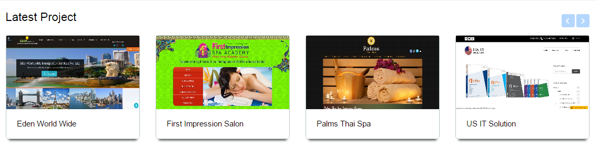

**Figure: 1.8**

**CHAPTER-2**

**MARKET SURVEY**

# 2.1 ASP.NET

Since 1995, Microsoft has been constantly working to shift its focus from windows-based platform to the internet As a result, Microsoft introduced ASP (Active Server Page) in November along with a new level of simplicity that made bit easy to understand and use.

However, ASP script was an interpreted script and consisted unstructured code and was difficult to debug and maintain. As the web consists of many different technologies, software integration for web development was complicated and required to understand many different technologies.

Also, as application grew bigger in size and became more complex, the number of lines of source code in ASP application increased dramatically and was hard to maintain. Therefore, an architecture was needed that would allow development of Web application in a structured and consistent way.

The .NET Framework was introduced with a vision to create globally distributed software with internet functionality and interoperability. The .NET Framework consist of many class libraries, includes multiple language support and a common execution platform. It’s a very flexible foundation on which may different types of top class application can be developed that do different things.

Developing Internet applications with the .NET framework is very easy. ASP.NET is build into this Framework, we can create ASP.NET application using any of the build-in languages. Unlike ASP, ASP.NET uses the common Language runtime (CLR) provided by the .NET Framework.

**2.2 Advantage Using ASP.NET:**

ASP.NET drastically reduce of code required to build large application ASP.NET makes development simpler and easier to maintain with an event-driven, Server side programming model ASP.NET pages are easy to write and maintain because the source code and HTML are together The source code is executed on the server.

The pages have lots of power and flexibility by this approach the source code is compiled the first time the page is requested. Execution is fast as the Web Server compiles the page the first time it is requested. The server saves the compiled version of the page for use next time the page is requested

* The HTML produced by the ASP.NET page is sent back to the browser. The application source code you write is not easily stolen
* ASP.NET makes for easy development. There is no need to register components because the configuration information is built-in
* The Web server continuously monitors the pages, components and applications running on it. If it notices memory leaks, infinite loops, other illegal software or activities, it seamlessly kills those activities and restart itself
* ASP.NET validates information (valid controls) entered by the user without writing a single line of code
* ASP.NET easily works with ADO.NET using data-binding and page formation features
* ASP.NET applications run faster and counter large volumes of user without performance problems

**2.3 Difference between ASP.NET & Client-side Language:**

Client-side refers to the browser and the machine running the browser. Server-side on the other hand refers to a Web server.

**2.3.1 Client-Side Scripting Language:**

Java Script and VBScript and generally used for Client-Side scripting. Client-Side scripting executes in the browser after the page is loaded. Using client-side scripting you can add some cool feature to your page. Both, HTML and the script are together in the same file and the script is downloaded as part of the page which anyone can view. A client-side script runs only on a browser that supports scripting the specifically language that is used.

**2.3.2 Server-Side Scripting Language:**

ASP.NET is purely server-side technology. ASP.NET code executes on the server before it is sent to browser. The code that is sent back to the browser is pure HTML and not ASP.NET code. Like client-side scripting, ASP.NET code is executed on the server and not in the browser and that prevent others from stealing the code you developed.

All .NET language creates code called intermediate language and as long as that code was written to the common language specification the intermediate language can be used by any other ,NET language. This means that all languages are first class languages as far as .NET is concerned. VB,NET is a .NET language with VB syntax. Most of the .NET facilities are available to VB.NET programmers, but interestingly

**2.4 C#:**

C# (pronounced “See Sharp”) is a multi-paradigm programming language encompassing imperative, functional, generic, object-oriented (class-based), and component-oriented programming disciplines. It was developed by Microsoft within the .NET initiative and later approved as a standard by Ecma (ECMA-334) and ISO (ISO/IEC 23270). C# is one of the programming languages designed for the common language infrastructure.

C# is intended to be a simple, modern, general-purpose, object-oriented programming language. Its development team is led by Anders Hejlsberg. The most recent versions is C# 4.0, which was released on April 12, 2010

**2.5 About Visual Studio 2010:**

In Visual Studio 2010, there is a print screen image of the software. It is a software that we used to develop our website.

* Visual Studio 2010 is software that used to develop the new application with very less effort.
* Designing of application becomes easy by this software.
* Visual Studio 2010 is used as frontend.

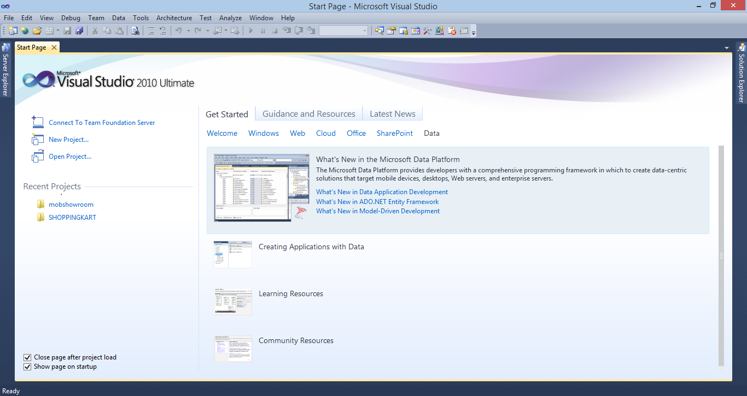

**Figure: 2.1**

**MICROSOFT VISUAL STUDIO 2010**

**2.6 Designing Features:**

**2.6.1 Interoperability:**

Because computer systems commonly require interaction between newer and older applications, .NET Framework provides means to access functionality implemented in newer and older programs that execute outside .NET environment. Access to COM components is provided in system runtime interrupt services and System Enterprise Services namespaces of the framework; access to other functionality is achieved using the P/Invoke feature.

**2.6.2 Common Language Runtime engine:**

Common Language Runtime (CLR) serves as the execution engine of .NET Framework. All .NET programs execute under the supervision of CLR, guaranteeing certain properties and behaviors in the areas of memory management, security, and exception handling.

**2.6.3 Language independence:**

.NET Framework introduces a Common Type System, or CTS. CTS specification defines all possible data types and programming constructs supported by CLR and how they may or may not interact with each other conforming to Common Language Infrastructure (CLI) specification. Because of this feature, .NET Framework supports the exchange of types and object instances between libraries and applications written using any conforming .NET language.

**2.6.4 Framework Class Library:**

Framework Class Library (FCL) is a library of functionality available to all languages using .NET Framework. FCL provides classes that encapsulate a number of common functions, including file reading and writing, graphic rendering, database interaction, XML document manipulation, and so on. It consists of classes, interfaces of reusable types that integrate CLR.

**2.6.5 Simplified deployment:**

.NET Framework includes design features and tools which help manage the installation of computer software to ensure that it does not interfere with previously installed software, and that it conforms to security requirements.

**2.6.6 Security:**

The design addresses some of the vulnerabilities, such as buffer overflows, which have been exploited by malicious software. Additionally, .NET provides a common security model for all applications.

**2.6.7 Portability:**

While Microsoft has never implemented the full framework on any system except Microsoft Windows, it has engineered the framework to be platform-agnostic, and cross-platform implementations are available for other operating systems. Microsoft submitted the specifications for CLI (which includes the core class libraries, CTS, and the Common Intermediate Language) C#, and C++/CLI to both ECMA and ISO, making them available as official standards. This makes it possible for third parties to create compatible implementations of the framework and its languages on other platforms.

**2.7 Architecture:**

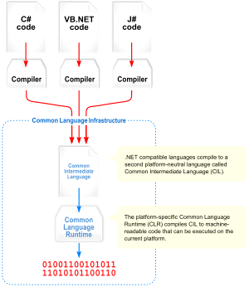

**Visual overview of the Common Language Infrastructure (CLI)**

**Figure: 2.2**

**2.7.1 Common Language Infrastructure (CLI):**

The purpose of CLI is to provide a language-neutral platform for application development and execution, including functions for exception handling, garbage collection, security, and interoperability. By implementing the core aspects of .NET Framework within the scope of CLI, this functionality will not be tied to a single language but will be available across the many languages supported by the framework. Microsoft's implementation of CLI is CLR.

**2.7.2 Main article: Assembly (CLI):**

Common Intermediate Language (CIL) code is housed in CLI assemblies. As mandated by the specification, assemblies are stored in Portable Executable (PE) format, common on Windows platform for all DLL and EXE files. The assembly consists of one or more files, one of which must contain the manifest, which has the metadata for the assembly. The complete name of an assembly (not to be confused with the filename on disk) contains its simple text name, version number, culture, and public key token. Assemblies are considered equivalent if they share the same complete name, excluding the revision of the version number. A private key can also be used by the creator of the assembly for strong naming. The public key token identifies which private key an assembly is signed with. Only the creator of the key pair (typically .NET developer signing the assembly) can sign assemblies that have the same strong name as a previous version assembly, since the creator is in possession of the private key. Strong naming is required to add assemblies to Global Assembly Cache.

**2.7.3 Security:**

.NET has its own security mechanism with two general features: Code Access Security (CAS), and validation and verification. CAS is based on evidence that is associated with a specific assembly. CAS uses evidence to determine the permissions granted to the code. Other code can demand that calling code is granted a specified permission. The demand causes CLR to perform a call stack walk: every assembly of each method in the call stack is checked for the required permission; if any assembly is not granted the permission a security exception is thrown.

|  |
| --- |
| Namespaces in the FCL |
| System |
| System. Diagnostics |
| System. Globalization |
| System. Resources |
| System. Text |
| System.Runtime.Serialization |
| System. Data |

**2.7.4 Class library:**

**Table: 2.1**

.NET Framework includes a set of standard class libraries. The class library is organized in a hierarchy of namespaces. Most of the built-in APIs are part of eitherSystem.* or Microsoft.* namespaces. These class libraries implement a large number of common functions, such as file reading and writing, graphic rendering, database interaction, and XML document manipulation, among others. .NET class libraries are available to all CLI compliant languages. .NET Framework class library is divided into two parts: FCL and Base Class Library (BCL).

FCL includes a small subset of the entire class library and is the core set of classes that serve as the basic API of CLR. Classes in mscorlib.dll and some classes in System.dll and System.core.dll are part of FCL. FCL classes are available in .NET Framework as well as its alternative implementations including.NET Compact Framework, Microsoft Silver light and Mono.

BCL is a superset of FCL and refers to the entire class library that ship with .NET Framework. It includes an expanded set of libraries, including Windows Forms,

**2.8 Comparison:**

**2.8.1 Comparison between .NET and JAVA:**

|  |  |
| --- | --- |
| **JAVA** | **.NET** |
| **Java** is both a programming language as well as a well-developed technology.  It was found by Sun Micro Systems. | .Net is a framework found by Microsoft which supports multiple languages like VC#,VC++ |
| **Java** source code is converted to Byte Code by JVM. | While in **.NET** code id converted to MSIL (Microsoft Intermediate Language Code) by the CLR supported by .NET. |
| **Java** is a single language shared by multiple platforms. | **.Net** is a framework for different languages but shared by single platform |
| It runs on several operating systems including Windows, Mac and Linux. .. | Net is primarily for Windows. |
| While **Java** is based on third-party tool and server providers. | **.Net** has a more integrated development environment, as the IDE, runtime and server all come from Microsoft as a standard package, |
| At least not when used to develop web applications. For desktop applications, | .Net naturally has an edge in Windows integration. note: Oracle bought Sun Microsystems (Sun). |
| Where as in **java**, code for creating a simple control like button also takes a lot of programming for a developer. | **.NET** provide more user friendliness when designing the forms for example in .net we drag and drop controls into form |
| The main difference is that java supports connected architecture. . Secondly, Java is a programming language. | .Net is a platform which supports multiple language supports disconnected Architecture. |

**Table: 2.2**

**2.8.2 Comparison between ASP and ASP.NET:**

|  |  |
| --- | --- |
| **ASP** | **ASP.NET** |
| **ASP** has limited oops support and no built in support for xml. | **ASP .NET** is fully Object Oriented Programming. |
| Limited development and debugging tool is available. Very difficult to debug code. | **ASP.NET** has full xml support for easy data exchange. |
| In **ASP** only two languages are available for scripting, like VB script and Jscript/JavaScript. | Different types of tools and compilers available. Mostly as a development framework visual studio users more. |
| **ASP** is not well structured. ASP has mixed html and server side scripting. | Very easy to debug code. **ASP.NET** We can use C# or VB.NET as server side coding. |
| Error handling system is very poor in ASP. | Error handling is very good. |
| n you must place all directives on the first line of a page within the same delimiting block. For example:  <%LANGUAGE="VBSCRIPT" CODEPAGE="932"%> | In **ASP.NET**, you are now required to place the Language directive with a Page directive |
| **ASP** is Interpreted language based on scripting language like JavaScript and VB script. | State management support |
| In classic **ASP** if you want to update any code then need to often stop and restart the server. | SP.NET allows slew features that allow dynamically update and recognized.  Ø  Inbuilt validations controls are provided in **ASP.NET**. which are easy to implement |

**Table: 2.3**

**2.8.3 Comparison between VB.NET and CLASSIC VISUAL BSASIC:**

|  |  |
| --- | --- |
| **VB.NET** | **VB** |
| VB.NET is a truly object-oriented programming language. It supports inheritance, encapsulation and polymorphism. | It is object based programming language.  Inheritance, encapsulation and polymorphism. Are not supported. |
| The developer can create web-forms using. | Using for write text and create normal Gui based application. |
| VB.NET supports web-services | Not supported. |
| VB.NET supports multi-threading. | It is a multi-tier. |
| VB.NET supports structured exception handling. | UDT is the choice in VB. |
| VB.NET has great XML support  Changed syntax. | Not supported. |
| Whether Visual Basic .NET should be considered as just another version of Visual Basic or a completely different language is a topic of debate. | VB.NET is a version of vb. And support completely different language is a topic of debate. |
| He Long [data type](http://en.wikipedia.org/wiki/Data_type) has been doubled in length from 32 bits to 64 bits. This is true for all versions of VB.NET. | Two important data-type changes occurred with the move to VB.NET: compared to VB6, the Integer [data type](http://en.wikipedia.org/wiki/Data_type) has been doubled in length from 16 bits to 32 bits’ |
| The things that have changed significantly are the semantics-from those of an object-based programming language running on a [deterministic](http://en.wikipedia.org/wiki/Deterministic), | VB developers have to deal with when coming to the language, although this is somewhat addressed by the feature in Visual Studio 2005. |

**Table: 2.4**

**2.9 Language Features:**

* Like the [BASIC](http://en.wikipedia.org/wiki/BASIC) programming language, Visual Basic was designed to accommodate a steep [learning curve](http://en.wikipedia.org/wiki/Learning_curve). Programmers can create both simple and complex [GUI](http://en.wikipedia.org/wiki/Graphical_user_interface) applications. Programming in VB is a combination of visually arranging [components](http://en.wikipedia.org/wiki/GUI_widget) or [controls](http://en.wikipedia.org/wiki/GUI_widget) on a [form](http://en.wikipedia.org/wiki/Form_(programming)), specifying attributes and actions for those components, and writing additional lines of code for more functionality.
* Though VB programs can be compiled into native code executable [from version 5 on](http://en.wikipedia.org/wiki/Visual_Basic#Timeline_of_Visual_Basic_.28VB1_to_VB6.29), they still require the presence of around 1 MB of runtime libraries. Runtime libraries are included by default in [Windows 2000](http://en.wikipedia.org/wiki/Windows_2000) and later. Earlier versions of [Windows](http://en.wikipedia.org/wiki/Microsoft_Windows) (95/98/NT) require that the runtime libraries be distributed with the executable.
* Alternatively, a Visual Basic component can have no user interface, and instead provide ActiveX objects to other programs via [Component Object Model](http://en.wikipedia.org/wiki/Component_Object_Model) (COM). This allows for server processing or an add-in module.

**2.10 Application of .NET:**

* An application on the Web may consist of several ASP files that work together to perform some purpose. The Application object is used to tie these files together.
* The Application object is used to store and access variables from any page, just like the Session object. The difference is that ALL users share ONE Application object (with Sessions there is ONE Session object for EACH user).
* The Application object holds information that will be used by many pages in the application (like database connection information). The information can be accessed from any page. The information can also be changed in one place, and the changes will automatically be reflected on all pages.

**2.11 Characteristics:**

The following Visual Basic traits differ from C-derived languages:

* Statements tend to terminate with keywords, such as "End If", instead of using "{}"s to group statements.
* Multiple variable assignments is not possible. A = B = C does not imply that the values of A, B and C are equal. The Boolean result of "Is B = C?" is stored in A. The result stored in A would therefore be either false or true.
* [Boolean](http://en.wikipedia.org/wiki/Boolean_datatype) constant True has numeric value −1.This is because the Boolean data type is stored as a 16-bit signed integer. In this construct −1 evaluates to 16 binary 1s (the Boolean value True), and 0 as 16 0s (the Boolean value False).
* This is apparent when performing a Not operation on a 16 bit signed integer value 0, which returns the integer value −1, in other words True = Not False.
* Logical and bitwise operators are unified. This is unlike some C-derived languages (such as [Perl](http://en.wikipedia.org/wiki/Perl)), which have separate logical and bitwise operators. This again is a traditional feature of BASIC.
* Variable [array](http://en.wikipedia.org/wiki/Array_data_type) base. Arrays are declared by specifying the upper and lower bounds in a way similar to [Pascal](http://en.wikipedia.org/wiki/Pascal_(programming_language)) and [FORTRAN](http://en.wikipedia.org/wiki/Fortran).
* It is also possible to use the Option Base statement to set the default lower bound. Use of the Option Base statement can lead to confusion when reading Visual Basic code and is best avoided by always explicitly specifying the lower bound of the array.
* Relatively strong integration with the [Windows operating system](http://en.wikipedia.org/wiki/Microsoft_Windows) and the [Component Object Model](http://en.wikipedia.org/wiki/Component_Object_Model). The native types for strings and arrays are the dedicated COM types, BSTR and SAFEARRAY.

## 2.12 History:

* VB 1.0 was introduced in 1991. The drag and drop design for creating the user interface is derived from a prototype form generator developed by [Alan Cooper](http://en.wikipedia.org/wiki/Alan_Cooper) and his company called Tripod Microsoft.
* Tripod did not include a programming language at all. Microsoft decided to combine Ruby with the Basic language to create Visual Basic.
* Visual Basic 1.0 (May 1991) was released for Windows at the Comdex/Windows World trade show in Atlanta, Georgia.
* Visual Basic 1.0 for [DOS](http://en.wikipedia.org/wiki/DOS) was released in September 1992. The language itself was not quite compatible with Visual Basic for Windows, as it was actually the next version of Microsoft's DOS-based BASIC compilers.
* Visual Basic 2.0 was released in November 1992. The programming environment was easier to use, and its speed was improved. Notably, forms became insatiable objects, thus laying the foundational concepts of class modules as were later offered in VB4.
* Visual Basic 3.0 was released in the summer of 1993 and came in Standard and Professional versions. VB3 included version 1.1 of the Microsoft that could read and write Jet (or Access) 1.x databases.
* Visual Basic 4.0 (August 1995) was the first version that could create [32-bit](http://en.wikipedia.org/wiki/32-bit) as well as [16-bit](http://en.wikipedia.org/wiki/16-bit) Windows programs. It has three editions; Standard, Professional, and Enterprise.
* With version 5.0 (February 1997), Microsoft released Visual Basic exclusively for [32-bit](http://en.wikipedia.org/wiki/32-bit) versions of Windows. Programmers who preferred to write 16-bit programs were able to import programs written in Visual Basic 4.0 .
* Visual Basic 6.0 (Mid-1998) improved in a number of areas including the ability to create web-based applications. Visual Basic 6.0 has entered Microsoft's "non-supported phase" as of March 2008. Windows Vista, Windows Server 2008 and Windows 7.

**2.13 Definitions:**

* **ASP.NET framework 4.5 -** It is a programming platform, belonging to the Java platform, which is used for developing and running distributed .NET applications.
* **ASP (Active Server Pages)**: It is used to create dynamic web content.
* **SQL Server 2008 R2-** It is a database management system that provides a flexible and efficient database platform to raise a strong "on demand" business applications.
* **HTTP (Hyper Text Transfer Protocol)-** It is a transaction oriented client/ server protocol between a web browser and a web server.
* **Ajax (Asynchronous Java Script and XML):** It is a technique used in java script to create dynamic web pages.
* **Stored Procedure**: A stored procedure is a group of sql statements that has been created and stored in the database.

**2.14 Overall Description:**

**2.14.1 Product Perspective:**

**USER**

**HTTP**

**SQL Server**

**IIS**

**TCP/IP**

**Client Software (user)**

**Figure: 2.3**

**2.14.2 Hardware and Software Requirement:**

**Client Side Requirements:**

|  |  |
| --- | --- |
| Processor | Pentium (Dual core or i3 Suggested) |
| RAM | 512MB (1 GB suggested) |
| Memory | 10 GB (40 GB suggested for long term use) |
| Web Server | IIS(Internet Information Services) |

**Table: 2.5**

**Sever Side Requirements:**

|  |  |
| --- | --- |
| Processor | Pentium (Dual core or i3 Suggested) |
| RAM | 512MB (1 GB suggested) |
| Memory | 10 GB (40 GB suggested for long term use) |
| Web Browser | Internet Explorer 7.0 or higher |

**Table: 2.6**

**2.14.3 Communication Interfaces:**

* The Login page from which among the two users (Admin, User) can login and will move to their respective web pages.
* User is allowed to create a Work Permit and mail it for approval to higher authority. The Work Permit is then approved and further it is closed by the closing team. The user can view various reports of the Work Permit.

**2.15 Product Functions:**

**2.15.1 Validation of Administrator/User:**

The Administrator and the general user have been provided with unique login id and password. Only valid user can browse through their corresponding interfaces in the sites.

**2.15.2** **Personal Details:**

The administrator can create a new user, edit the details of an existing user and can also delete an already existing user.

The personal information of other user can not be accessed. The administrator on the other hand has can view the personal details of the entire user.

**2.15.3 Photo Gallery:**

The administrator can add /upload new images relating to the Company. She/he can also delete any of the existing images that are been currently been viewed on the site. The general user can view all the images on the site.

**2.15.4 Events:**

The administrator can add new events that are going to place at the company Management. The user can get the details about all the events that are to be taken place in the *SHOPPINGKART.*

**2.15.5 Search/Retrieval of Information:**

Both the administrator and the general user can perform the search functions. Search can be information regarding the Company Product.

**2.16 Front-End & Back-End Used:**

Front-end and Back-end are terms use to characterize program interfaces and services relative to the initial user of these interfaces and services. (the user may be a human being or a program)

A ”Front-End application” is one that application users interact with directly. A “Back-End application” or program serves indirectly in support of the front-end services, usually by being closer to the required resource or having the capability to communicate with the required resource. The Back-End application may interact directly with Front-end or perhaps more typically, is a program called from an intermediate program that mediates front-end and back-end activities.

**2.16.1 Front-End Tool:**

**Introduction to .NET:**

The .NET framework introduces a completely new model for the programming and deployment applications. .NET is a Microsoft’s Vision of “software as a service”, a deployment environment in which you can build, create, and deployed your applications. Microsoft introduced great technologies like COM, DCOM, and COM+ etc. to enable reuse of software.

**2.16.2 Back-End Tool:**

**SQL:**

SQL is a powerful relational database management system that offers a large feature set.

**2.17 Specific Requirements:**

**Functional Requirements:**

* Administrator Log-In Module:

Input: Password

Process: Verify Password

Output: Access Granted

* Update Module:

Input: Current information

Process: Validation of information, Database Updation.

Output: Update Website

**2.18 Non Functional Requirements:**

**Reliability:** The Application is able to represent company Product

**Ease of use and speed:** Less response time will aid in retrieving the information  **Performance:** Any number of user can access the site at the same time. Time taken to preview changes is adequate.

**Quality:** Site provides good interface to the user. So, the user has to make effort.

**Availability:** All the services provided by the system would be available almost every time as it is a web application.

**2.19 About Visual Studio 2010:**

Visual Studio is a complete set of development tools for developing ASP.NET Web application, XML Web Services, desktop application, and mobile application. Visual Basic C++, Visual C#, and Visual J# all use the same integrated development environment (IDE), which approves them to share tools helps in the creation of mixed-language solution. In addition, these languages control the functionality of the .NET Framework, which arrange for access to key technologies that simplify the development of ASP Web applications and XML Web Services. Visual Studio 2010 Express missing quite a bit of features such as MFC or ATL, and lacks Windows GUI libraries and includes files. It means that users probably can’t develop Windows GUI application using the Express edition.

**2.20 SQL Server 2008:**

SQL server 2008, released in August 2008 is the next group of Microsoft SQL server and has been developed with a host of new features. This version of SQL server introduced powerful abilities such as support for procedure based management, checking, large scale data ware housing, geo spatial data, data management, advanced reporting and analysis services, etc.

Microsoft SQL server is a very popular and broadly situated general purpose database server supported on Windows server operating system. Microsoft has constantly place in to ensure that SQL server provides a complete general purpose database platform that is competitive with Oracle, IBM DB2, and My SQL.

A database is basically a collection of inter related data and set of program to access the data. This collection of data is usually called the data base

Management of data involves:

* Define the structure for the storage of data.
* Providing the mechanism for the security of data against unauthorized access.

Database is providing the following facilities among others:

* Adding empty files to the database.
* Inserting new data into the existing files.
* Retrieving data from the files.
* Update data in the files.
* Deleting data from the files.
* Removing files from the database.

**2.21 Difference between My Sql & Sql Server:**

|  |  |
| --- | --- |
| **MY SQL** | **SQL SERVER** |
| My SQL is available for free since My SQL is an open source | SQL Server is not an open source and payment has to be made to use SQL Server. |
| My SQL offers only updateable views. | SQL Server offers indexed views which are much more powerful, performance wise. |
| My SQL does not support XML. My SQL provides only table level security. | SQL Server supports XML SQL Server provides column level security |
| Stored procedures and full join facility is not offered in My SQL.Import and Export functions have very limited support in My SQL. | Stored procedures and full join facility are offered in SQL Server.Import and export are extensively supported in My SQL |
| Transaction support is very much limited in My SQL. | Transaction support is extensively and fully offered in SQL Server. |
| Online backup support and clustering support is limited in My SQL.Log Shipping and Storage Area Network support is not available in My SQL. | Log Shipping and Storage Area Network support is available in SQL Server.Online backup support and clustering support is extensive and complete in SQL Server. |
| OLAP Services, Data Reporting and Data Mining are not supported in My SQL. | OLAP Services, Data Reporting and Data Mining are supported in SQL Server |

**Table: 2.7**

**2.22 Working with an ASP.NET Application:**

After creating an ASP.NET application, the ASP.NET files need to be stored on a Web server such as Internet Information Services (IIS) server, which is the Web server for the Windows platform. The Web server process the ASP.NET files and then executes the script. Finally, the results are sent to the Web browser that required the ASP.NET file.

A web server generates and sends only the HTML output to the client. As a result, it help to hide the code of the ASP.NET files from the users who access an ASP.NET web page. The web browser interprets the output and displays it.

ASP.NET script engine is the engine that processes the server side script contained in an ASP.NET application. After processing the scripts, the engine renders the result as an HTML document and sends it back to the browser. The web server forwards the ASP.NET file to the ASP.NET script engine for processing.

ASP.NET Runtime

(Include ASP.NET script engine)

Request .aspx is processed

HTML page is generated

Web server

Request .aspx file is Loaded and sent to ASP.NET

Script engine for processing

HTML Page

**Request.aspx file**

**HTML response**

**2.22.1 The ASP.NET Provider Model:**

ASP.NET 2.0 includes a number of services that store state in database and other storage media. A provider is a software element that provides a uniform interface among a service and a data source Provider’s perceptual physical storage media, in much the same way that device drivers abstract physical hardware devices. Because almost all ASP.NET 2.0 state-management services are provider-based, storing conference state or connection state in an oracle database rather than a Microsoft SQL Server database is as simple as working in oracle session state and membership provider.

This whitepaper documents the ASP.NET 2.0 provider model and providers the crucial information that developers needs to write strong, high-quality providers. Provider model has same kind of goals which is below. Provider model is also knows as namespace which is used to interface between services and data source.

**2.22.2 Goals of the Provider Model:**

* The ASP.NET 2.0 provider model was designed with the following goals in mind:
* To make ASP.NET state storage both malleable and extensible
* To isolate application-level code and in the ASP.NET run-time from the physical storage media where state is stored, and to isolate the change required to use different media types to a single well-defined layer with nominal surface area
* To make writing custom providers as simple as possible by providing a robust and well-documented set of base classes from which developers can provider classes of their own.

**2.22.3 Provider Types:**

Association is one of several ASP.NET 2.0 services that use the provider architecture. Table 1 documents the features and services that are provider-based and the default providers that service them:

**Feature or Service: Default Provider:**

Role management: System.Web.Security.SqlRoleProvider

Profile: System.Web.Profile.SqlProfileProvider

Session state: System.Web.SessionState.InProcSessionStateStore

**2.23 Features of ASP.NET:**

ASP.NET has some kind of advanced features. Through this features asp.net is very popular,

Features are following:-

1. **Compile code:** The code written in ASP.NET is compiled and not interpreted. This makes ASP.NET application faster to execute than other server side scripts.
2. **Power and flexibility:** ASP.NET application is based on CLR.As a result, the power and flexibility of the .NET platform is available to ASP.NET application.
3. **Simplicity:** ASP.NET enables you to build user interfaces that single application logic from the presentation content.
4. **Manageability:** ASP.NET enables you to manage web application by storing the configuration information in an Extensible markup language (XML) file.
5. **Scalability:** ASP.NET has been designed with scalability in mind. It has that help grow performance in a multiprocessor environs.
6. **Security:** ASP.NET provides a number of options for implementing security and restricting user access to a Web application.

**CHAPTER-3**

**WORK I DID**

**3.1 About Project:**

The working on the project “**Shoppingkart.com**” was an extremely learning experience. I came across no. of new concepts and also enhanced our technical knowledge. I was capable to overcome the position. I have used the ASP.NET in such a manner that this website is friendly with all the browsers like Internet explorer, Chrome, Firefox. Exact now this website is in the testing stage.

I have created a project of **Shoppingkart.com** in ASP.Net language. Now a days craze of online shopping in India is increasing rapidly because in present time online shopping is very easy and comfortable. With the use of online shopping we save money and time both so the growth of online shopping user in India day by day increase and many online store currently active which provide best deal and offers online which causes growth of online user increase. In India there are many online site which causes online user increase in India.

**3.1.1 Objective & Scope of project:**

The objective of our project is to develop an “Online Shopping” that will provide the facility to sell of that products.

The main motive of developing this project is to facilitate the following:

* To provide a common platform where all the information about ***“*www.shoppingkart.com*”*** is available to all the customers, dealers, staff and other users.
* ***“*www.shoppingkart.com*”*** is to work on behalf of the owner to complete a project within the plans and specifications provided

**3.1.2 Definition of Problem:**

To design a *“***www.shoppingkart.com***”* for customer who wants to sale on products from anywhere. It will fulfill the needs & requirements of clients. This dynamic, user friendly web application is use to explore & sell new company products.

**3.2 System Planning**

Planning is an important activity in software project management. When a **software project**

is planned, estimates of required human effort, chronological project duration and cost must

be derived. Effective management of a software project depends on thoroughly planning the

progress of the project.

The project schedule is given in the form of the Gantt chart given with the document:

|  |  |  |
| --- | --- | --- |
| **S. No** | **Activity** | **Time Duration** |
| 1 | Problem Definition | 4 days |
| 2 | Analysis | 2 days |
| 3 | Design | 4 days |
| 4 | Coding | 9 days |
| 5 | Testing | 3 days |
| 6 | Reporting & Documentation | 2 days |

**Table: 3.1**

**Gantt chart**

|  |  |  |  |  |  |  |
| --- | --- | --- | --- | --- | --- | --- |
| **Problem Definition** |  |  |  |  |  |  |
| **Analysis** |  |  |  |  |  |  |
| **Design** |  |  |  |  |  |  |
| **Coding** |  |  |  |  |  |  |
| **Testing** |  |  |  |  |  |  |
| **Reporting & Documentation** |  |  |  |  |  |  |

**Table: 3.2**

**3.3 Installation of Visual Studio 2010:**

**Step 1: Double click on setup.exe.**

**Step 2: After clicking setup.exe file, you will see the following screen. Click Install Microsoft Visual Studio 2010.**

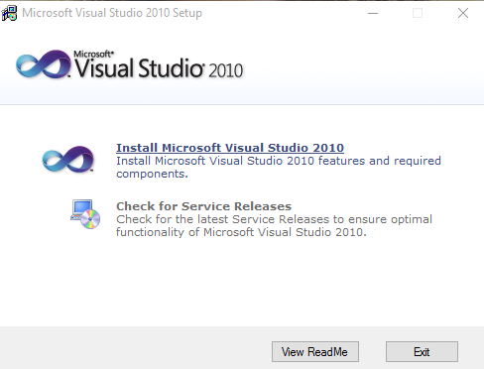

**Figure 3.1**

**Step 3: Click next to start installation.**

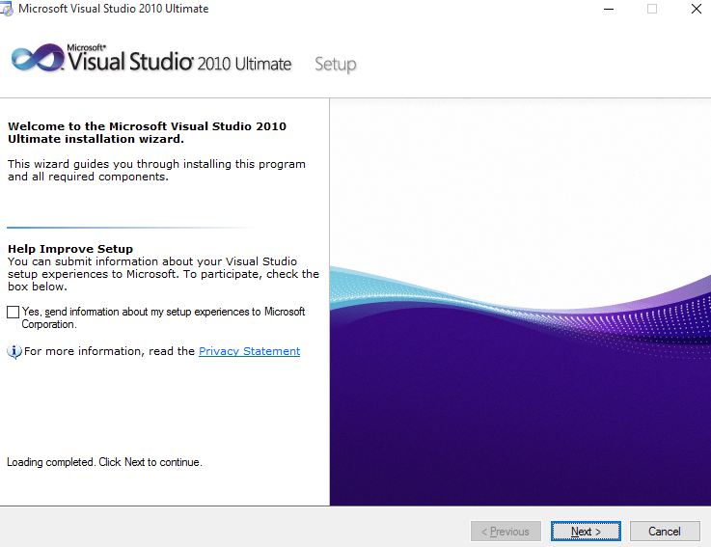

**Figure 3.2**

**Step 4: After clicking next you will see the following screen.**

**Step 5: Next Button to I Accept the License Term**

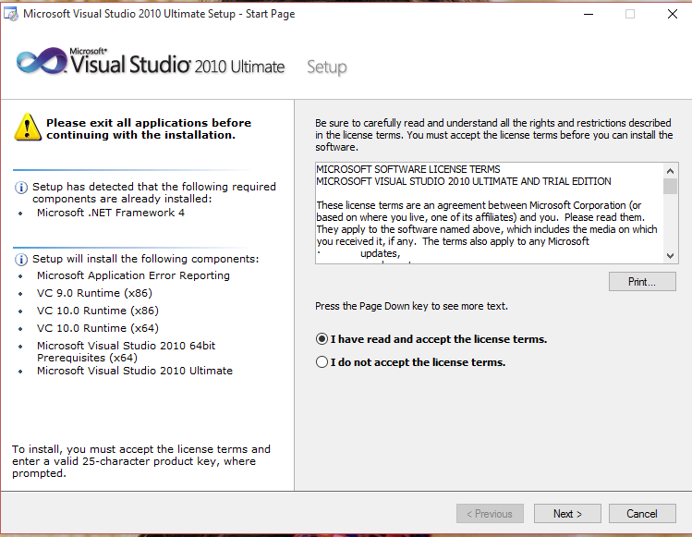

**Figure 3.3**

**Step 6: Select the features that you want to install and the path you want to install visual studio 2010. If you don’t select path it will install in default location. You can select either Full or Custom features. If you select custom you have to select features which you want to install. For the beginner I suggest to select full feature.**

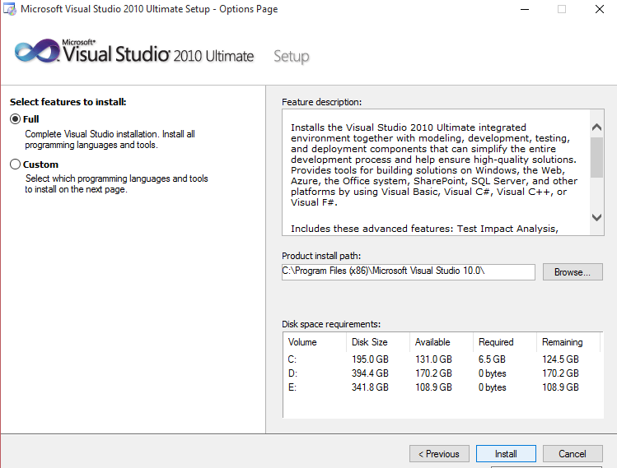

**Figure 3.4**

**Step 7: Then the setup will start to install its components.**

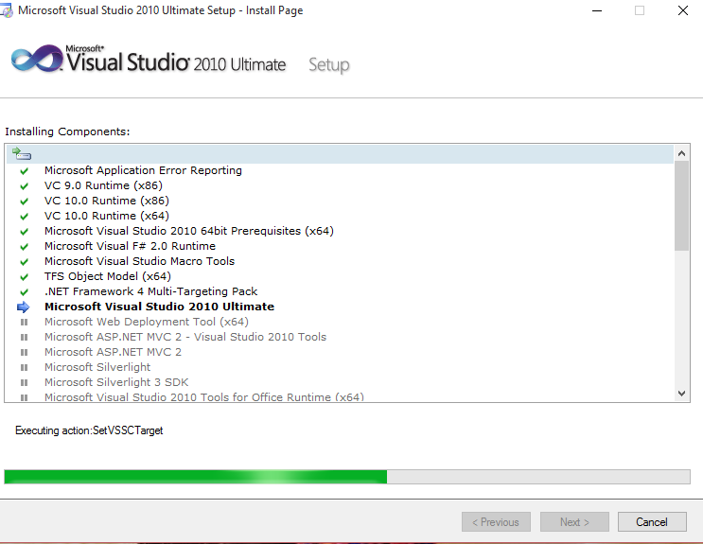

**Figure 3.5**

**Step 8: The installation complete.**

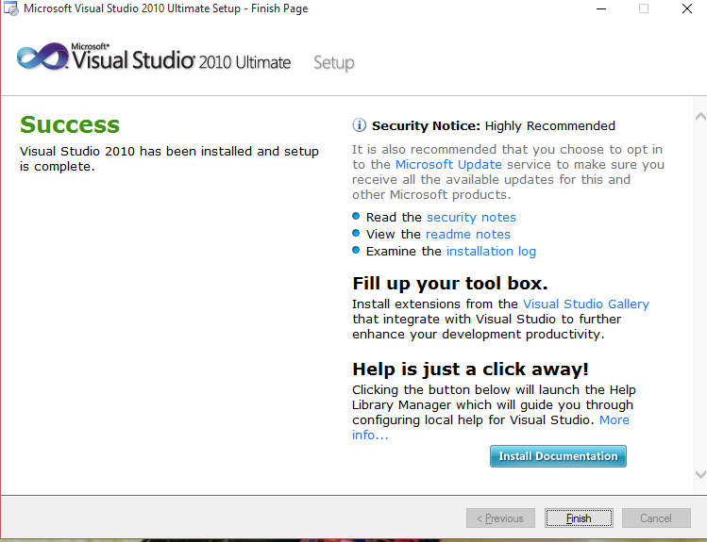

**Figure 3.6**

**3.4 Designing of Project:**

**3.4.1 Home Page:**



**Figure: 3.7**

This is our Home Page. It’s about shopping They can be used for them to buy Products. This Website can help for choose and select the better products and save our time.

In this page user can select the category, subcategory, and products and purchase what to want. In this website many categories like electronics, stationaries, Home & Furniture, books & Media Sports etc.

This page shows the overall latest products of the website those are new on website and all the popular products are shown on this page. In this page admin can add all types of category products that are popular or higher demand on the market.

**3.4.2 Men Page:**

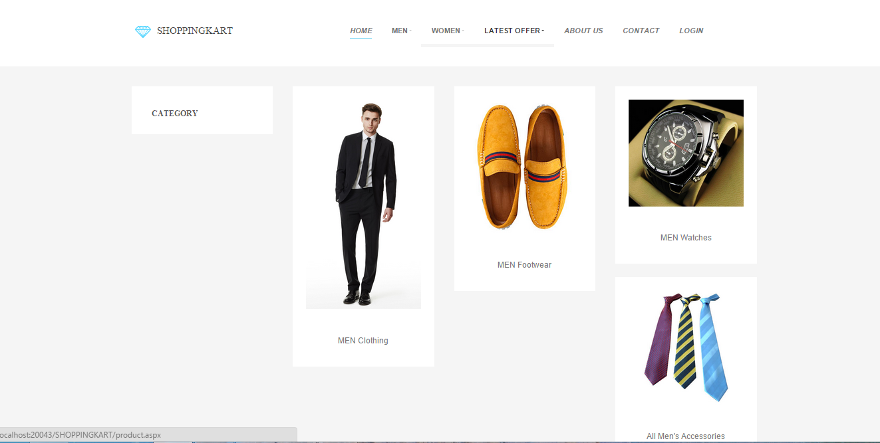

**Figure: 3.8**

This is the Second Page of our website which is known as Men Page. This page shows the overall Products of men’s products of the website. Such as Men’s Clothing, Footwear, Watches, Accessories, Fragrances, Sunglasses, Wallet, Jeans, belts Etc.

**3.4.3 Women Page:**

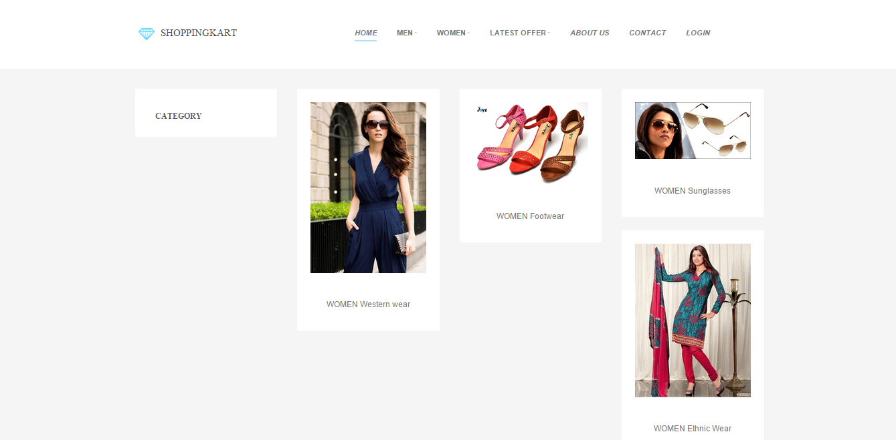

**Figure: 3.9**

This is the Third Page of our website which is known as Women Page. This page shows the overall Products Women’s products of the website. Such as Women’s Western wear, Footwear, sunglasses, Ethnic Wear, Jewelry, Watches, Perfumes Etc.

**3.4.4 Latest Offer Page:**

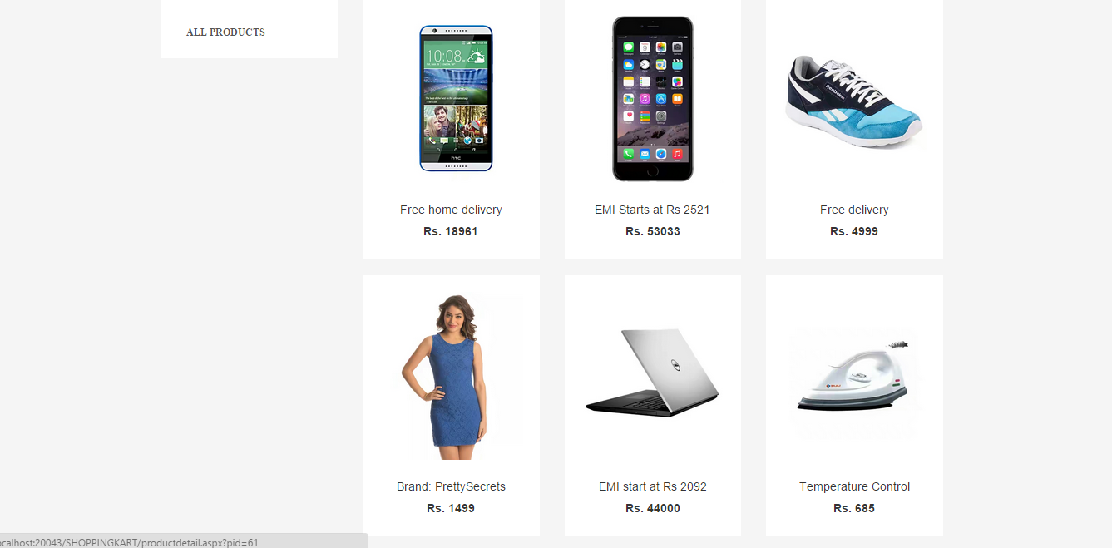

**Figure: 3.10**

This is the Fourth Page of our website which is known as Latest Offer Page. This page shows the overall latest products of the website those are new on website and all the popular products are shown on this page. In this page admin can add all types of category products that are popular or higher demand on the market.

**3.4.5 About us Page:**

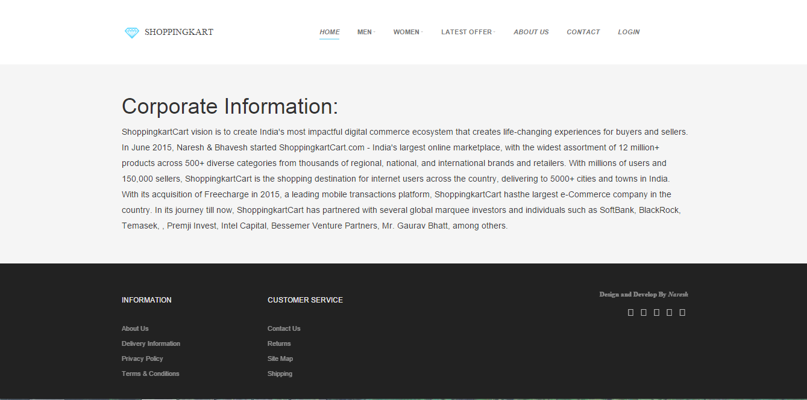

**Figure: 3.11**

This is the Fifth Page of our website which is known as Latest Offer Page. This page shows the Company information about the website.

**3.4.6 Contact Us Page:**

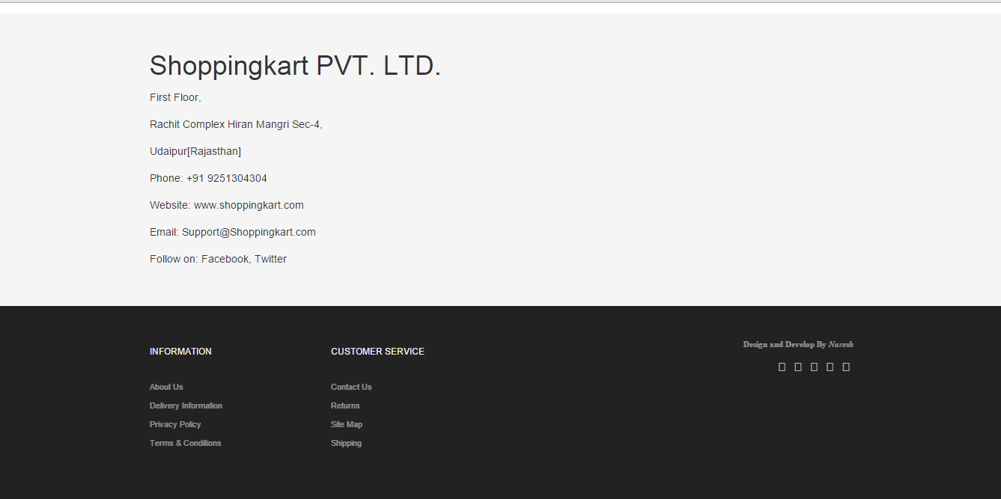

**Figure: 3.12**

This is the Sixth Page of our website which is known as Latest Offer Page. This page shows the contact information of the company website like address, phone number, email, Etc.

**3.5 Designing of Admin Panel:**

**3.5.1 Admin Login Page:**

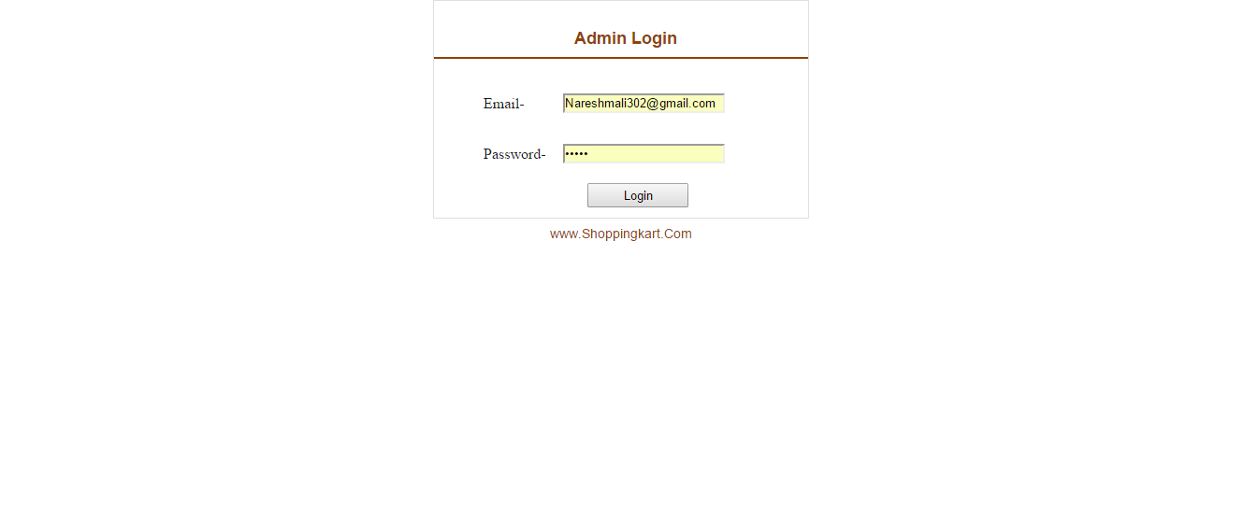

**Figure: 3.13**

This is the Seventh page of our website which is known as Login Page. Admin can login and make changes on the website through this admin page like add, delete, and update the products.

**3.5.2 Admin Panel Page:**

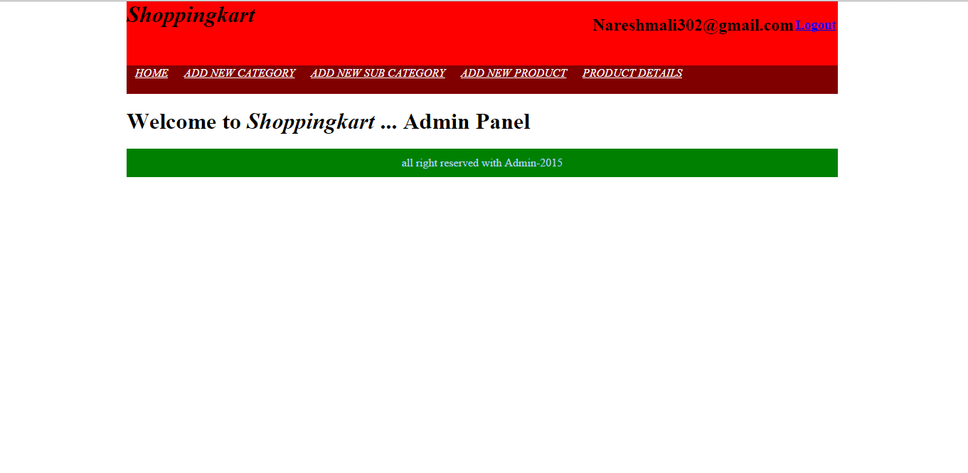

**Figure: 3.14**

This is home page of the admin panel. Through this page admin can select the pages like home, add new category, add new sub category add new product and product detail page.

**3.5.3 Add New Category Page:**

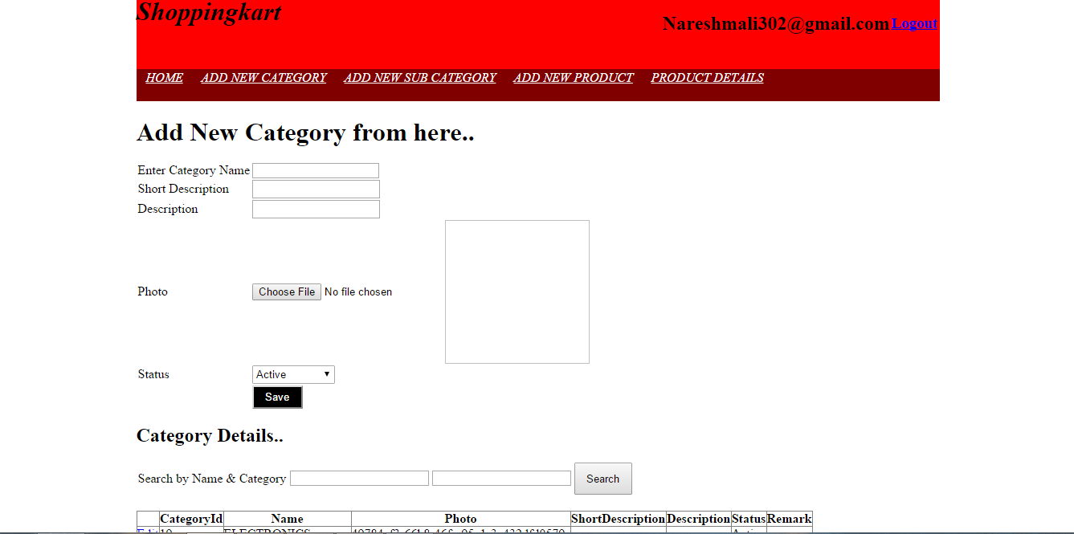

**Figure: 3.15**

This is the second page of the admin panel. In this page admin can add a category which are shown on website home page like electronics, stationaries, Home & Furniture, books & Media Sports etc.

**3.5.4 Add New Sub Category Page:**

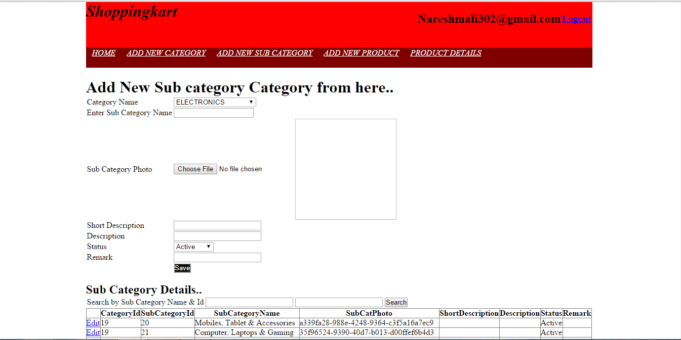

**Figure: 3.16**

This is the third page of the admin panel. In this page admin can add a sub category which is shown on website home page like mobile, laptop, television, wall clock and jeans etc.

**3.5.5 Add New Product Page:**

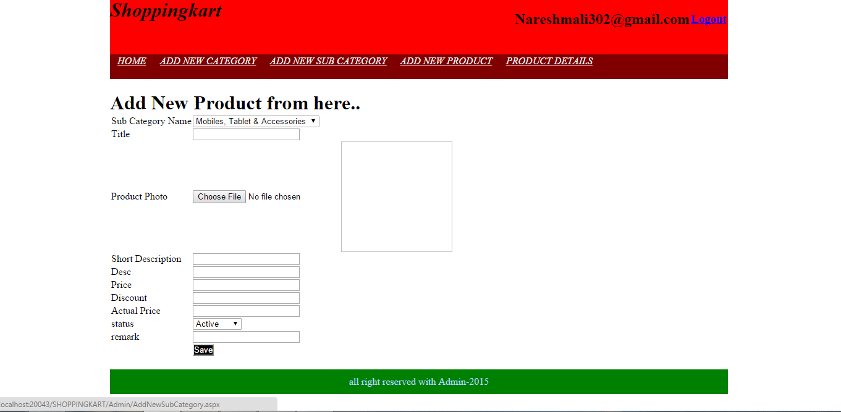

**Figure: 3.17**

This is the fourth page of the admin panel. In this page admin can add products which is shown on Website pages. Admin can add product title, short description, photo, description, price, discount, actual price, status, remark.

**3.5.6 Product Detail Page:**

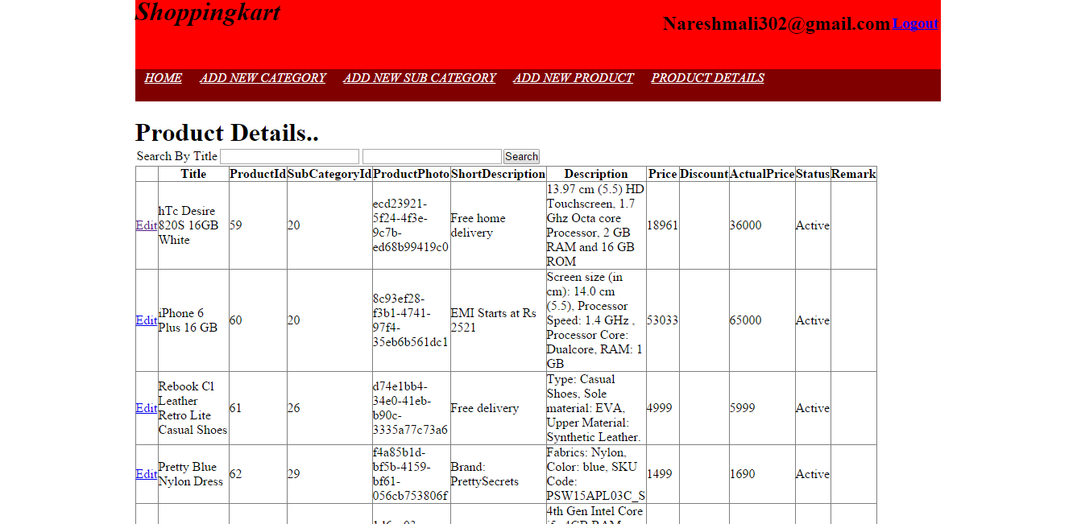

**Figure: 3.18**

This is the fifth page of the admin panel. This page can show the product detail which are add by the admin. In this page admin can make changes of the products to the edit button perform the save, update and delete operation. Or check the detail of the products.

**3.6 Designing of Database:**

**3.6.1 Category Table:**

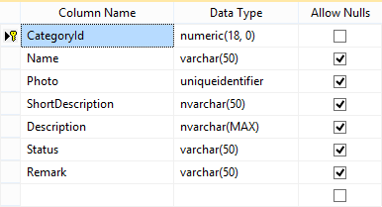

**Figure: 3.19**

This category table can shows for the detail of the database of the category fill by the admin.

**3.6.2 Product Table:**

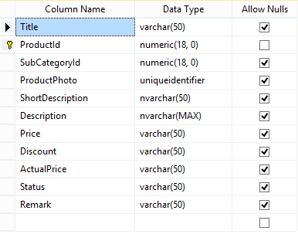

**Figure: 3.20**

This product table can shows for what detail of the database of the product fill by the admin.

**3.6.3 Sub Category Table:**

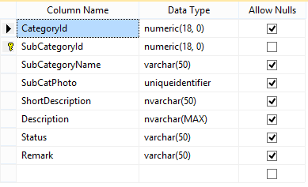

**Figure: 3.21**

This sub category table can shows for what detail of the database of the sub category fill by the admin.

**CHAPTER 4**

**DESIGN AND METHODLOGY**

**4.1 SOFTWARE DEVELOPMENT LIFE CYCLE:-**

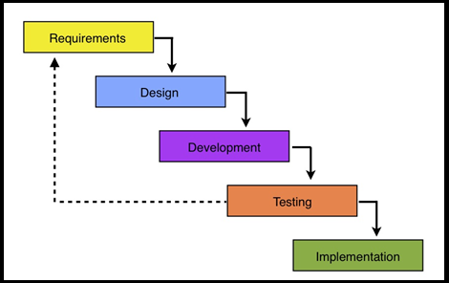

**Figure: 4.1**

**4.1.1 SDLC OVERVIEW:-**

SDLC, Software Development Life Cycle is a process used by software industry to

Design, develop and test high quality software. The SDLC aims to produce a high

Quality software that meets or exceeds customer expectations, reaches completion within

Times and cost estimates.

SDLC is the acronym of Software Development Life Cycle. It is also called as Software development process.

The software development life cycle (SDLC) is a framework defining tasks performed at each step in the software development process.

ISO/IEC 12207is an international standard for software lifecycle processes. It aims to be the standard that defines all the tasks required for developing and maintaining Software.

**4.1.2 What is SDLC ?**

SDLC is a process followed for a software project, within a software organization. It consists of a detailed plan describing how to develop, maintain, replace and alter or enhance specific software. The life cycle defines a methodology for improving the quality

of software and the overall development process.

**STAGE 1: Planning and Requirement Analysis:-**

Requirement analysis is the most important and fundamental stage in SDLC. It is performed by the senior members of the team with inputs from the customer, the sales department, market surveys and domain experts in the industry.

**STAGE 2: Defining Requirements:-**

Once the requirement analysis is done the next step is to clearly define and document the product requirements and get them approved from the Customer or the market analysts. This is done through ‘SRS’ –Software Requirement Specification document which consists of all the product requirements to be designed and

Developed during the project life cycle.

**Stage 3:Designing the product architecture**:-

SRS is the reference for product architects to come out with the best architecture for the product to be developed. Based on the requirements specified in SRS, usually more than one design approach for the product architecture is proposed and documented in a DDS -Design Document Specification.

**Stage 4: Building or Developing the Product:-**

In this stage of SDLC the actual development starts and the product is built. The programming code is generated as per DDS during this stage. If the design is performed in a detailed and organized manner, code generation can be accomplished without much

**Stage 5: Testing the Product:-**

This stage is usually a subset of all the stages as in the modern SDLC models, the testing activities are mostly involved in all the stages of SDLC. However this stage refers to the testing only stage of the product where products defects are reported, tracked, fixed and retested, until the product reaches the quality standards defined in the SRS.

**Stage 6: Deployment in the Market and Maintenance:-**

Once the product is tested and ready to be deployed it is released formally in the appropriate market. Sometime product deployment happens in stages as per the organizations’ business strategy.

**4.2 TECHNOPEDIA USE CASE:-**

Use cases define interactions between external actors and the system to attain particular goals. There are three basic elements that make up a use case:

**Actors:** Actors are the type of users that interact with the system.

**System:** Use cases capture functional requirements that specify the intended behavior of the system.

**Goals:** Use cases are typically initiated by a user to fulfill goals describing the activities and variants involved in attaining the goal.

Use cases are modeled using unified modeling language and are represented by ovals containing the names of the use case. Actors are represented using lines with the name of the actor written below the line. To represent an actor's participation in a system, a line is drawn between the actor and the use case. Boxes around the use case represent the system boundary.

**4.1.1 DESIGNING OF USE CASE:-**

Identify the users of the system for each category of users, create a user profile. This includes all roles played by the users relevant to the system.

Identify significant goals associated with each role to support the system. The system’s value proposition identifies the significant role.

Create use cases for every goal associated with a use case template and maintain the same abstraction level throughout the use case. Higher level use case steps are treated as goals for the lower level.

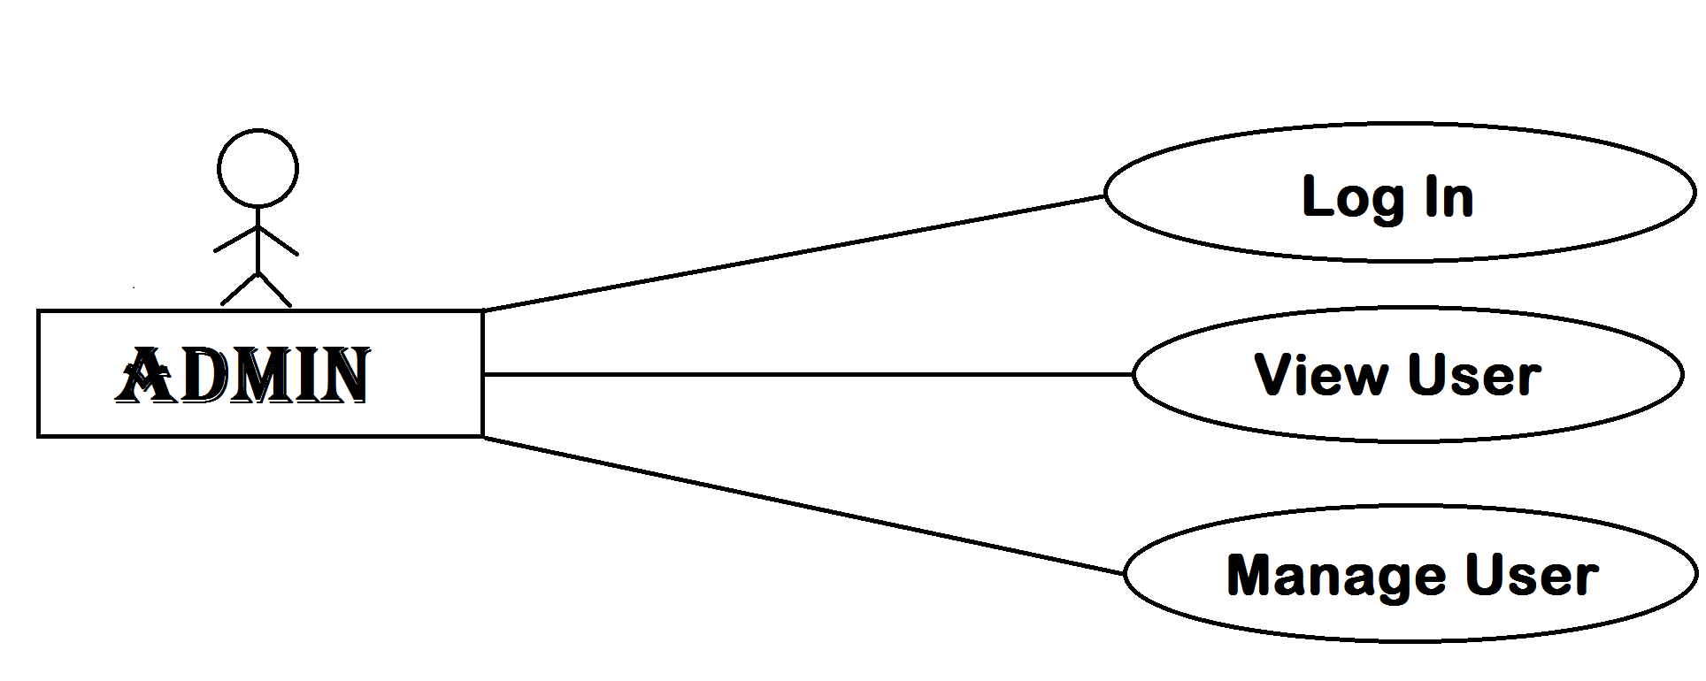

**Figure: 4.2**

**4.2 DATA FLOW DIAGRAMS:-**

* A data flow diagram is graphical tool used to describe and analyze movement of data through a system. These are the central tool and the basis from which the other components are developed.
* The transformation of data from input to output, through processed, may be described logically and independently of physical components associated with the system. These are known as the logical data flow diagrams.
* The physical data flow diagrams show the actual implements and movement of data between people, departments and workstations. A full description of a system actually consists of a set of data flow diagrams. Using two familiar notations Yourdon, Gane and Sarsen notation develops the data flow diagrams.
* Each component in a DFD is labeled with a descriptive name. Process is further identified with a number that will Sbe used for identification purpose. The development of DFD’S is done in several levels. Each process in lower level diagrams can be broken down into a more detailed DFD in the next level.
* The lop-level diagram is often called context diagram. It consists a single process bit, which plays vital role in studying the current system. The process in the context level diagram is exploded into other process at the first level **DFD**.
* The idea behind the explosion of a process into more process is that understanding at one level of detail is exploded into greater detail at the next level.
* This is done until further explosion is necessary and an adequate amount of detail is described for analyst to understand the process. Larry Constantine first developed the DFD as a way of expressing system requirements in a graphical from, this lead to the modular design.
* Questionnaires should contain all the data elements that flow in and out. Missing interfaces redundancies and like is then accounted for often through interviews.
* **Bubble** :A circle is used to show to a process. Both input and outputs to a process are dataflow. It is illustrate in figure

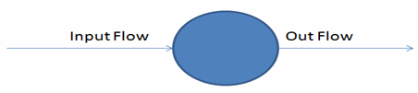

**Figure: 4.3** input/output flow

* **Arrow**: Data flows are represented by a line through an arrow.

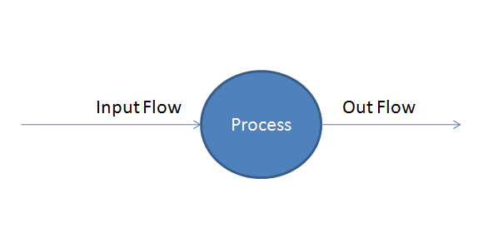

**Figure: 4.4** Processes

* **Rectangle**: Rectangle is used to symbolize the entities and is outside the system.Designer does not have several controls greater than them. They furthermore supply or receive data.

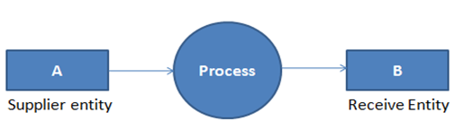

**Figure: 4.5** Representation of entity

* **Parallel Lines:** Parallel Lines are used to represent data stores. Process could store or Receive data from data stores. Data cannot Flow between Two data stores. An arrow towards data store is a sign of writing data to store and an arrow from data stores depicts recovery of data from it.

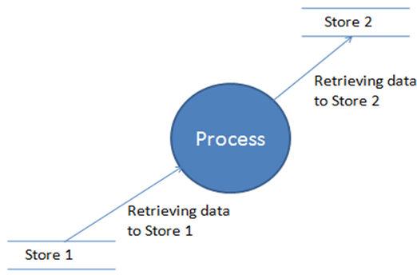.

**Figure: 4.6** Data Collection and process

**4.3 E-R Symbols:**

|  |  |  |
| --- | --- | --- |
| **S.N** | **Symbol** | **Entity** |
| 1 | E | Entity set |
| 2 |  | Attribute |
| 3 | E | Weak entity set |
| 4 |  | Multi valued attribute |
| 5 | R | Relationship set |
| 6 | R | Relationship set for weak entity set |
| 7 | E  R | Total participation of entity set |
| 8 |  | Primary key |
| 9 |  | Is criminating attribute of week entity set |
| 10 | R | Many to many |
| 11 | R | Many to one relationship |
| 12 | R | One to one relationship |
| 13 |  | ISA or generalization |
| 14 |  | Total generalization |

**Table: 4.1**

**SUMMARY & CONCLUSION**

As the practical training of 24 working days has been provide to me. I completed my practical in the fixed duration with my satisfaction even through period was not wide and detailed study of .net framework is not possible, but I have tried to collect the more information about .net framework, SQL server and Microsoft visual studio.

The working on the project “**Shoppingkart.com**” was an extremely learning experience. I came across no. of new concepts and also enhanced our technical knowledge. I was capable to overcome the position. I have used the ASP.NET in such a manner that this website is friendly with all the browsers like Internet explorer, Chrome, Firefox. Exact now this website is in the testing stage.

I have created a project of **Shoppingkart.com** in ASP.Net language. Now a days craze of online shopping in India is increasing rapidly because in present time online shopping is very easy and comfortable. With the use of online shopping we save money and time both so the growth of online shopping user in India day by day increase and many online store currently active which provide best deal and offers online which causes growth of online user increase. In India there are many online site which causes online user increase in India.

In this Project report, I have thanked to all the people who helped me in my project work. After that I had written some line about my company from where I have completed my Project. Then I have described about my project that what I did in my website, what all I learnt etc. I added snapshot of all the websites that I have created and designed of my website. I have also added snapshot of all the tables which I have used for my website in the database.

Although we have faced many crisis during the designing and the thoughtful part but remaining to the good support of our team and the direction given through our teachers.

**RESULT & FUTURE ENHANCEMENT**

**Result:**

This project can be used to test the basic knowledge of ASP.NET, SQL, C#.....etc. It can be upgraded further with certain other features.ASP.NET fully meet the system for which it has been develop. The system has reached a steady state where all bugs have been eliminated the system is operated at a high level of efficiency and all the teachers and user associated with the system understands its advantages. Our project Shoppingkart.com is developed in the ASP.NET frame work. We used Visual studio 2010 to create this website. **www.shoppingkart.com**

**Future Enhancement:**

**System Development:**

In future I will add extra technique and ways to develop this website. We will also distinguish attractive designing effect.

So wherever it require I will use according to design. And I will also try to add new technology and newest idea. I will tried our best to meet their expectation.

**Increase Security Level:**

In future I will increase the security level of our website. This time I have not given return code for security but in future will tried to work on this option. This will be our main focus on our website.

**Provide Many Options:**

I will add Online Payment Facility for Users can also buy the online products with directly through server.

**Add Search Option in Our Website:**

In future I will give the search option for our website so that user can easily search a particular field required to wedding Website.

**REFERENCE**

I am used various type of books and websites from which I get the Knowledge about ASP.NET. Which are following:-

1. Fundamentals of Software Engineering. New Delhi: Prentice-Hall India.

2. Software Engineering, Girdhari Singh, Shalini Puri.

3. Fundamental of Software Engineering Rajib mall, Phi.

4. Essential of Dot Net Programming Theory and Application (Sanjib k Sahu).

5. The Complete Reference MySQL, VikramVaswani, TMH.

6. WWW.Google.com.

7. WWW.W3schools.com.

8. Photoshop.

9. WWW.code Project.com